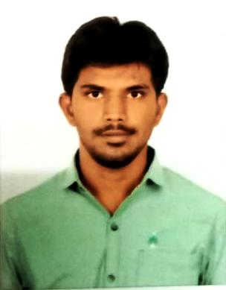  Permanent Address:  S/O Mr. K.Rajendran  2/53, N.Kovilpatti  Noothulapuram (Post)  Nilakkottai (Taluk)  Dindigul (District) – 624202  Tamil Nadu (India).  Contact Details:  Mobile:  +91-7358695907  E-mail:  rananthan04.care@gmail.com  Personal Data:  Date of Birth : June 20,1991  Gender : Male  Nationality : Indian  Marital Status : Single  Personal Skills:  - Reliable & Professional  - Time Management  - Fast Learner  - Team Player  Languages Known:  - Tamil  - English  Interests:  - Interested in meeting and interacting with people  - Love to travel to new places and learn the local culture  - Social work  - Photography  - Driving | ANANTHAN R  Career Objective  To perform, utilizing my skills and knowledge, in a manner which will contribute to the successful growth of the organization and help me to land in a successful career.  Academic Qualifications  - Post Graduation in Solar Energy passed in Distinction with 86.7% from College of Engineering,Guindy,Anna University, Chennai, TN, April 2016.  - Under Graduation in Mechanical Engineering passed in First class with 79.5% from CARE School of Engineering,Anna University, Trichy, TN, April 2013.  - Higher Secondary Schooling with 77.8% from N.S.V.V. Boys Hr.Sec School, Pattiveeranpatti,Dindigul, TN, March 2009.  - High School with 84% from R.C. High School, Siliukkuvarpatti,Dindigul, TN, April 2007.  Software Skills  - Auto CAD  - TRYNSYS  Technical Skills  - Solar system designing and Analysis.  - Knowledge about thermal system,Dynamic system analysis.  Involved in Projects  CTDT:  - Synchronous reluctance machines for wheel chair applications.  Post Graduation:  - Techno economic feasibility study of solar parabolic trough collector for Sizing mills.  Under Graduation:  - Experimental study on design and performance analysis of self circulating bio gasification system.  Work Experience  1). Company : CEG,Anna University,Chennai.  Position : Project Associate-I (6 Months)  Department : Competetive Exams  Period of work : Jan 20, 2020 to Present  2). Company : Karpaga Vinayaga College of Engineering and Technology  Position : Assistant Professor (1 Academic year)  Department : Teaching  Period of work : June 27,2016 to April 30,2017  3). Company : Air Calibre Systems  Position : HVAC Service Engineer (1 year 2 Months)  Department : Service  Period of work : May 2, 2013 to July 30,2013.  Declaration  I hereby declare that the above information is true and correct to the best of my knowledge and belief.  Place: Chennai Yours faithfully  Date:22.11.2020 (ANANTHAN.R)

